In-Memory DBMS

⚡ What Is an In-Memory DBMS?
# Source: AI Source: Provided by: [Data Path: Persons Table -> ID Column: 1, Name_En Column: Motasem Essam] -> From: [ChatGPT] on [6/10/2026]
An In-Memory Database Management System (In-Memory DBMS) is a type of database that stores all data directly in the main memory (RAM) instead of on traditional disk storage (like HDD or SSD).
This makes it extremely fast for reading and writing data — often 10x to 1000x faster than disk-based databases.

🔍 Key Characteristics
# Source: AI Source: Provided by: [Data Path: Persons Table -> ID Column: 1, Name_En Column: Motasem Essam] -> From: [ChatGPT] on [6/10/2026]
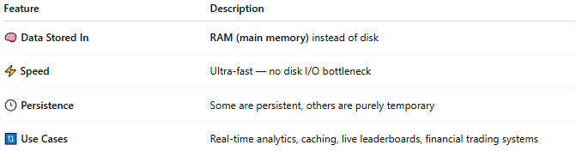
Feature | Description
🧠 Data Stored In | RAM (main memory) instead of disk
⚡ Speed | Ultra-fast — no disk I/O bottleneck
🕒 Persistence | Some are persistent, others are purely temporary
🔃 Use Cases | Real-time analytics, caching, live leaderboards, financial trading systems

🧠 Why So Fast?
# Source: AI Source: Provided by: [Data Path: Persons Table -> ID Column: 1, Name_En Column: Motasem Essam] -> From: [ChatGPT] on [6/10/2026]
- Traditional DBMS:
➤ Read/write goes to disk (slower)
- In-Memory DBMS:
➤ Data stays in RAM (fastest part of a computer)

🧰 Examples of In-Memory DBMS
# Source: AI Source: Provided by: [Data Path: Persons Table -> ID Column: 1, Name_En Column: Motasem Essam] -> From: [ChatGPT] on [6/10/2026]
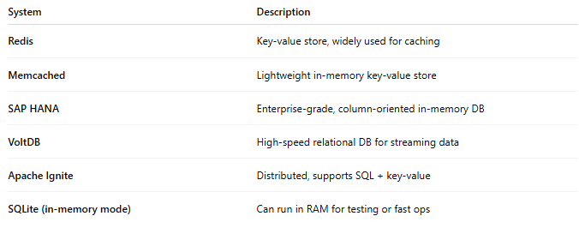
System | Description
Redis | Key-value store, widely used for caching
Memcached | Lightweight in-memory key-value store
SAP HANA | Enterprise-grade, column-oriented in-memory DB
VoltDB | High-speed relational DB for streaming data
Apache Ignite | Distributed, supports SQL + key-value
SQLite (in-memory mode) | Can run in RAM for testing or fast ops

🧭 Use Cases
# Source: AI Source: Provided by: [Data Path: Persons Table -> ID Column: 1, Name_En Column: Motasem Essam] -> From: [ChatGPT] on [6/10/2026]
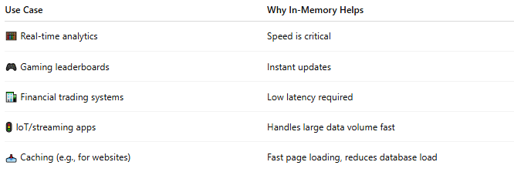
Use Case | Why In-Memory Helps
🧮 Real-time analytics | Speed is critical
🎮 Gaming leaderboards | Instant updates
🏦 Financial trading systems | Low latency required
🚦 IoT/streaming apps | Handles large data volume fast
📥 Caching (e.g., for websites) | Fast page loading, reduces database load

⚖️ Pros and Cons
# Source: AI Source: Provided by: [Data Path: Persons Table -> ID Column: 1, Name_En Column: Motasem Essam] -> From: [ChatGPT] on [6/10/2026]
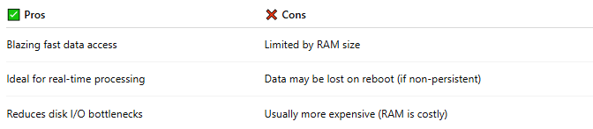
✅ Pros | ❌ Cons
Blazing fast data access | Limited by RAM size
Ideal for real-time processing | Data may be lost on reboot (if non-persistent)
Reduces disk I/O bottlenecks | Usually more expensive (RAM is costly)

📌 Summary
# Source: AI Source: Provided by: [Data Path: Persons Table -> ID Column: 1, Name_En Column: Motasem Essam] -> From: [ChatGPT] on [6/10/2026]
An In-Memory DBMS is optimized for speed by storing data in RAM instead of disk. It's used where performance and real-time access matter more than long-term storage.

